**CSSE3101 – ADVANCED WEB TECHNOLOGIES**

**SHORT TEST**

**SPRING SEMESTER AY 2022-2023**

**SECTION I: 10 marks**

***Instructions:*** Make a folder TEST on Desktop. Copy the exam work file **(mobile.html)** and place files in your folder. Open the file **mobile.html** and answer all the questions.

**WIREFRAME**

|  |  |
| --- | --- |
| Navigation | |
| Mobile Online Shop | Form  Payable |

**EXAMPLE OUTPUT**

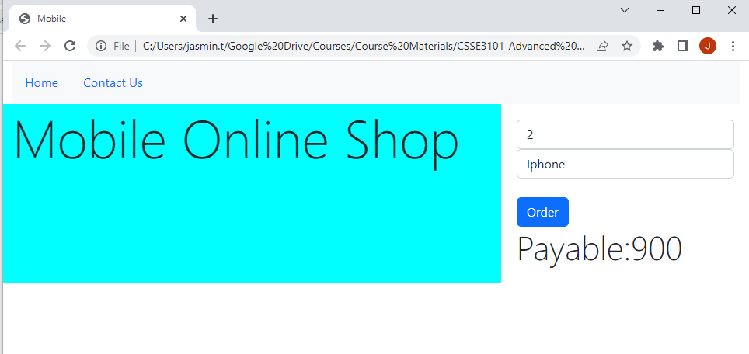

1. Refer to the wireframe given to create the required web page layout.
2. Create the layout using Bootstrap Grids. *[3 marks]*
3. Specify the appropriate Bootstrap classes for the elements in the navigation. *[1 mark]*
4. For the column containing the “Mobile Online Shop” apply the following bootstrap styles:
   * 1. Use any of the display classes for the text. *[0.25 mark]*
     2. Specify any background color. *[0.25 mark]*
5. Apply bootstrap classes for form controls. *[0.5 mark]*
6. Create the following JavaScript function:
   1. computePayable()
7. Function description – Computes the payable by using the computation below. Display also the payable.
   * + 1. Payable = Quantity * Price of Brand *[1.5 mark]*
       2. Price of brand: Iphone = 450, Oppo =350 *[1.5 mark]*
8. Parameter – quantity and brand  *[1 mark]*
9. Function invocation – when the user clicks the Order button  *[1 mark]*